Philadelphia University
Faculty of Information Technology Department of Software Engineering
Marking Schema
Lecturer : Dr. M. Maouche
Coordinator : Dr M. Maouche
Internal Examiner : Dr. A. Moayad

Course Name: Software Modeling (721222) Sections: 2
First Exam
First Semester Academic Year: 2014/15 Date: November, 20th , 2014 Time: 60 minutes
Question1: (8 marks)

1. Structure; behavior; interaction (2)

2. links express relationships between objects while associations express relationships between classes . (2)

3. Facilitate communication (1); Reduce complexity (2)

3. Abstraction (1); Separation of Concern (1)

Question2: (11 marks)
- Properties:

Name Type
tv-power : on | off (1,5)
sound-volume : 0..10 (1,5)
selected-tv-channel: 0..100 (1,5)
tv-device-working-status : out-of-order | signal on current channel
| no-signal on current channel (1,5)

- Operations

Mutators:
void tv-powerOn(); void tv-powerOff ();
void select-tv-channel (ch: 0..100);
void set-sound-volume (volume: 0..10)

Accessor:
0..10 get-sound-volume ()

Question3: (4 marks)
- (2)

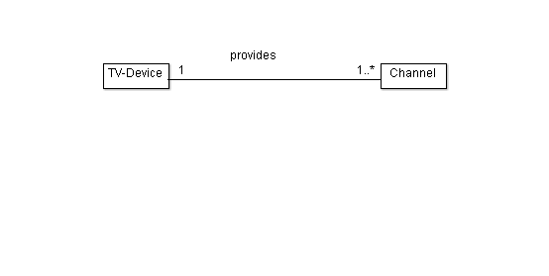

2.
activated-channel : Channel (1)
available-channels: set of Channel (1)

